Microaggressions in the Workplace and Diversity through Mentoring

Ella Urdaneta

MGMT 353

Professor Burnett

Team 8

Background Information
Strategic Human Resource Management (SHRM) is important for an organization as it focuses on solving the issues that affect the management of people. SHRM mainly deals with how the employee exhibits their skills and focuses on the problems affecting the business externally (Bratton & Gold, 2017). Human resources (HR), on the other hand, are the people who work in an organization and are solely responsible for managing employee resources. HR professionals are significant in an organization as they are involved in interviewing, recruiting, placing workers, and screening all the workers within an organization. According to an organizational behavior study by Bratton & Gold (2017), results indicate that people behave and act differently while they are in groups and this affects how they perform various activities within an organization. Organizational behavior helps us to know how employees should behave, motivate them, increase their performance, and build strong relationships with employees.
Microaggressions in the workplace and diversity through mentoring significantly affect organizational practices in various ways. Microaggression in the workplace is the daily verbal or non-verbal behaviors that are intentional or unintentional that communicate negative messages directed towards a certain marginalized group (Agarwal, 2019). These messages are not intended to cause any harm. Microaggressions can cause negative work relations, thus inhibiting smooth workflow between the workers. Diversity in the workplace becomes significant in terms of gender, ethnicity, and age.
Mentoring programs organized by the organizations can be used to facilitate diversity in the workplace. Mentoring is significant as it embraces differences by the employees, thus enhancing diversity. Mentoring is meant to develop the skills and confidence of the employees. It also helps in making employees establish excellent communication skills and thus perfecting on professional relationships. It can also help employees on how to deal with microaggressions. An example of an organization that has embraced mentoring to enhance diversity and microaggressions at the workplace is the Coca-Cola Company. It involves its employees in diversity education programmes (“10 Companies Around the World Embracing Diversity in a BIG Way,” 2016). These programmes have reaped many benefits to the company, making it one of the world's most known companies. The chart below indicates that companies that have adopted mentoring have better financial returns and thus success.
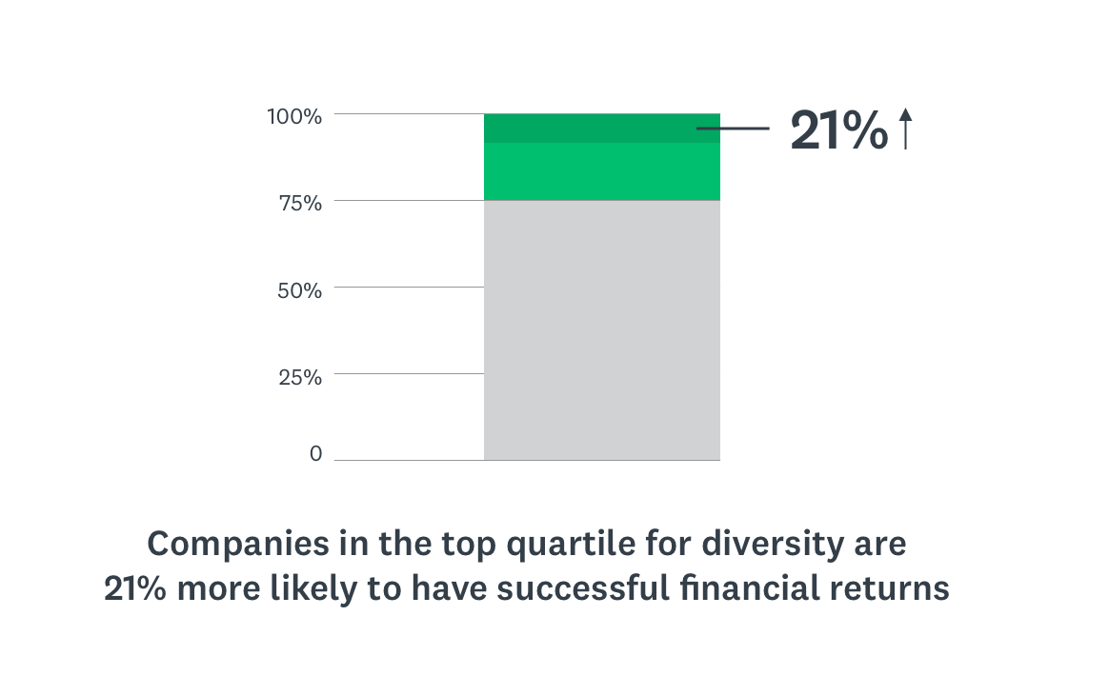

Literature Review
Today’s culture allows people to express themselves freely on how they feel about themselves and others without fear of the consequences. At the workplace, people enjoy different conversations about life, family, and relationships. When having conversations about these topics, some issues might not be addressed delicately, resulting in conflict and misunderstandings within the organization (Spencer, 2017). In the workplace, various aspects should be avoided, as they are likely to cause conflicts. Examples of these topics include religion, politics, and race. For instance, during work, one of the colleagues engaged in hate speech by suggesting how he did not like Muslims in the midst of a person of Islamic faith. This resulted in a conflict that took time to resolve. In most cases, microaggressions are felt mainly in the most unintentional forms. People often say offensive words to others when they are not aware that they are likely to cause harm to others.
Embracing mentoring at the workplace is helpful, as employees feel free to raise issues that were previously difficult to handle. Through mentoring, employees learn how to become sensitive in identifying statements that are not likely to cause harm. According to Spencer (2017), research indicates that people can avoid microaggressions at the workplace by listening and understanding what others say, accepting and growing, and practicing patience and learning (Spencer, 2017). Organizations are implementing this by constantly training their workers on better communication methods to avoid hurting others unintentionally. Mentoring, on the other hand, retains diversity at the workplace. Findings indicate that one-third of large organizations in the United States involve their workers in mentoring. Mentoring improves relationships between cultures, thus embracing diversity within an organization (Palsa & Rosser, 2007). Mentoring people within an organization enhances an understanding of gender differences that exist and thus overcome them (Palsa & Rosser, 2007). There is extensive growing evidence showing mentoring impacts diversity and microaggressions positively. Companies should, therefore, embrace mentoring as it leads to the improvement of organizational behavior. The pie chart below shows the significance of mentoring in organizations.
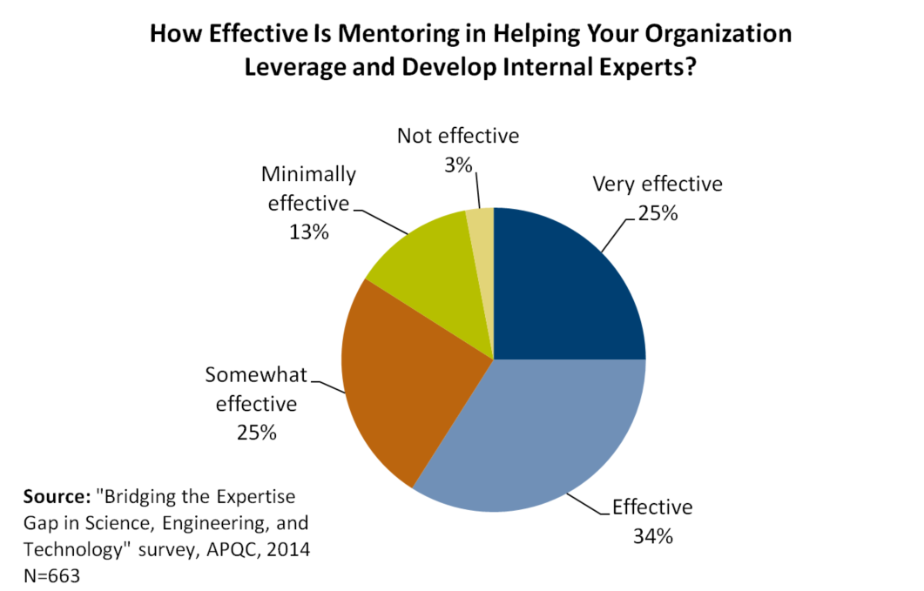

Propositions
Microaggression and diversity mentoring at the workplace can positively influence employees' attitudes and behaviors, leading to the company's success. For instance, Apple Inc. success is greatly contributed by mentoring its workers and enhancing diversity at workplaces by ensuring racial and gender equality across all its stores. This would result in both tangible and intangible benefits realized within an organization. Diversity and microaggressions mentoring will enhance an environment that promotes equal opportunities for all. Employees will be willing to cooperate, and there will be positive benefits felt within the organizations, as employees will be empowered (Kantor, 2018). Mentorship will promote the building of career paths by the employees, thus enabling the organization to reach its top goals, as employees are likely to provide the best. Top talents will be discovered as a result of microaggressions and diversity mentorship in the workplace. Lastly, informal relationships will be created between employees resulting in better work relationships, thus avoiding conflicts that are likely to occur as a result of negative relationships (Kantor, 2018).

Suggested Research
For further understanding of how mentoring can be used at the workplace to improve on diversity and microaggression, further research will be significant. First, I would research different techniques of mentoring that would be adopted in limiting microaggressions and enhancing diversity within the workplace. I will also do further research to determine if women are likely to benefit from mentoring rather than men in increasing microaggressions and diversity within an organization as few research has been conducted on the same. Necessary measures when carrying out the above research that would be conducted would include survey questions and the research population. The study area would be an essential measure to consider too. Data would be collected using online surveys whereby I would send a list of questions to different organization employees and invite them to participate in the surveys. I would later gather the findings and analyze the results.

Findings
From the study to be conducted, various results are likely to be collected. From the list of mentoring techniques that I will have provided in the online surveys such as mind mapping, use of open questions, appreciative inquiry, personal quality profile, and force field analysis, some techniques are likely to have higher results. Technologies like mind mapping and open questions are most likely to be one of the most effective mentoring methods, so they need to be adopted by the mentors. From the other research, findings would indicate that women are more likely to benefit from mentorship programmes in comparison to men. This is because women are more likely to follow mentorship programmes offered by organizations, as indicated by the high attendance of women in mentorship programmes in various organizations. Worldwide report on mentorship programmes indicates that mentoring is on the rise as 71 percent of organizations have embraced mentorship. These organizations have reported that mentorship was important for the success of the company.

Recommendations
In response to the presentation, HR managers will come up with various changes within an organization. The following plan will be valuable in ensuring changes within the organization. Tracking the attendance of members in mentorship programmes that enhance diversity within an organization. Ensuring communication effectiveness within the organization to avoid microaggressions of the employees in an organization. Tracking the changes because of mentorship programmes. HR managers should, therefore, be sensitive when addressing the employees to avoid microaggressions within an organization. They should always remind the workers to embrace diversity within the organization.

References
10 Companies Around the World Embracing Diversity in a BIG Way. (2016, August 7). SocialTalent. https://www.socialtalent.com/blog/recruitment/10-companies-around-the-world-that-are-embracing-diversity
Agarwal, P. (2019, March 29). How Microaggressions Can Affect Wellbeing In The Workplace. https://www.forbes.com/sites/pragyaagarwaleurope/2019/03/29/how-microaggressions-can-affect-wellbeing-in-the-workplace/#63a0519673cb
Bratton, J., & Gold, J. (2017). Human resource management: Theory and practice. Palgrave.
Kantor, Julie. (2018, October 24). Diversity + Mentoring = Increased Inclusion in the Workplace. https://www.linkedin.com/pulse/diversity-mentoring-inclusion-julie-kantor
Palsa, M. M., & Rosser, M. H. (2007). Mentoring and Diversity: A Review of the Literature. Online Submission.
Spencer, M. S. (2017). Microaggressions and social work practice, education, and research.

